**Working with Git**

1. Checking installed version of git

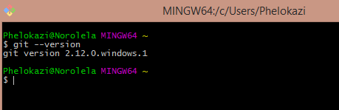

1. Git configuration and register your name to changes you make on projects.

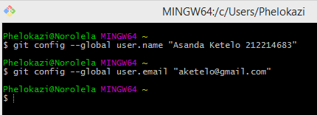

1. Check configuration values

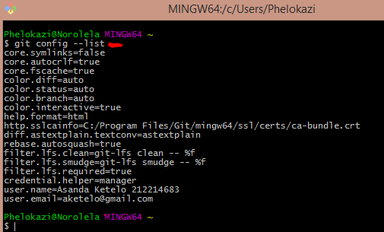

1. Two common cases to use git on

* Tracking existing project in your local machine.
* Start development on a remote project

**Working on local project**

1. Initialize empty git local repository

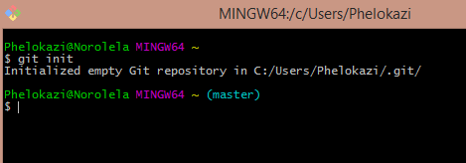

To change local repo to another location, just copy it.

1. Checking file in the local repo

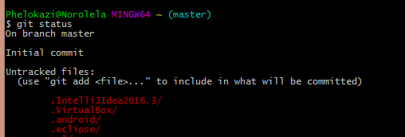

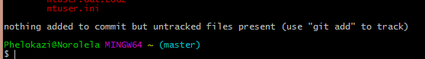

1. Ignoring files in local repo

…git ignore file created

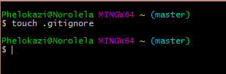

Add file names manually to .ignore text file NB/ use a wild card. Eg. */

1. Files in working directory are showed in red.

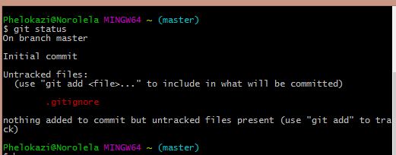

.gitignore is still untracked at the working directory.

1. File in staging area – tracked files, are showed in green

..add file individually to staging area

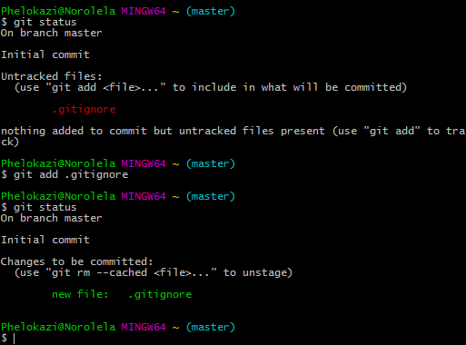

Git add –A to add all files into staging area.

1. To remove files from staging area

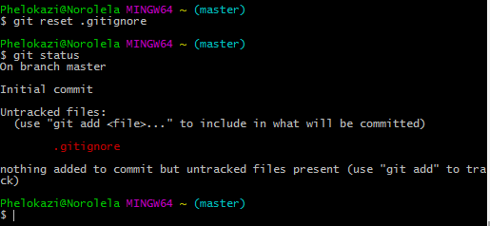

Git reset : will remove everything

1. Committing file from staging area.

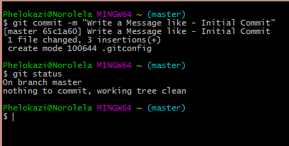

At this stage we do not have any modified files or untracked files:files have not been modified since last commit

1. Checking Status of the committed work.

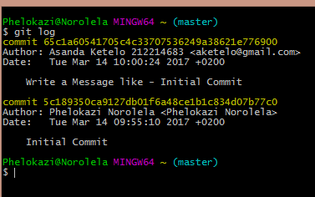

NB: Now we are successfully tracking our local project and committed files to our local repo.